VARSITY USER GUIDE:

# Login to VARSITY

* Go to the link : <http://172.17.31.152/varsity/>
* Give your Username and password

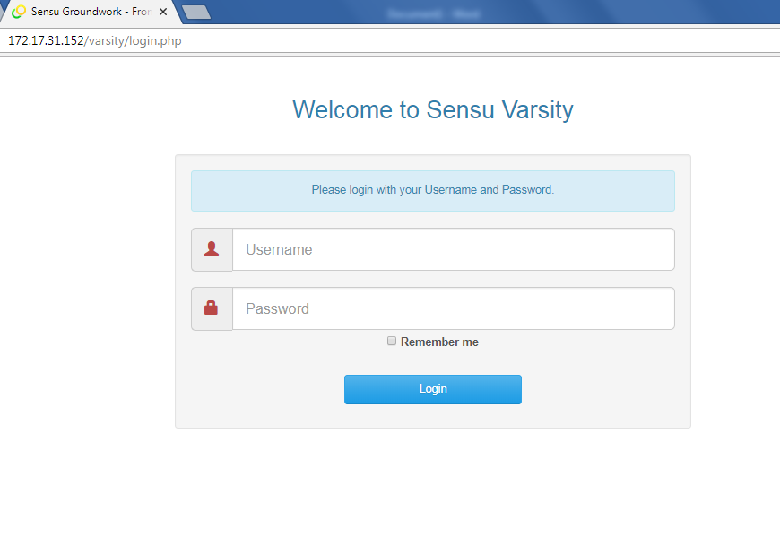

* Click login to log into Varsity

# CReating Hosts IN VARSITY

* Click on Create Host under “Main” menu in the right hand side of the Screen. 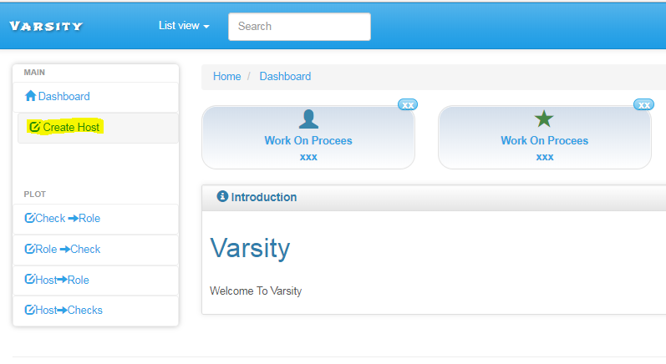
* Enter the IP address of the required host into the field and select the environment of the Server(Production/Stage) and click Submit to add the host. 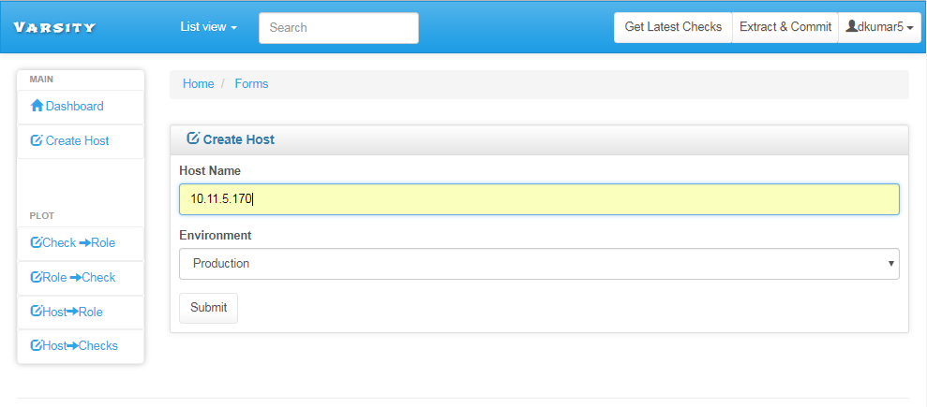

# View ALL checks in a ROLE

* To view all the checks present in a particular role, go to Roles -> Check under View menu. 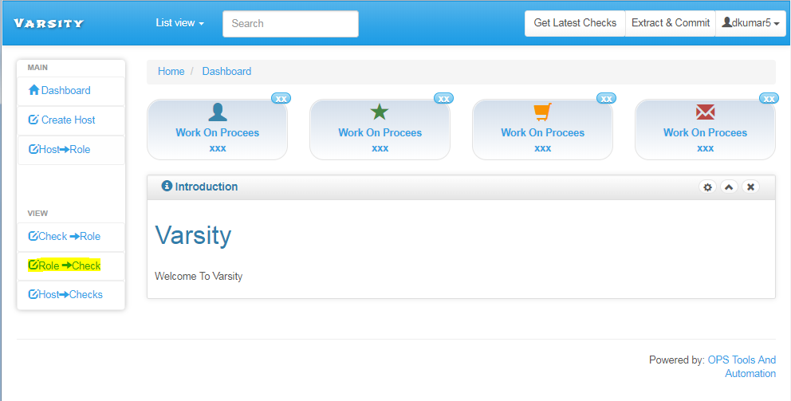
* Select the required role name for which you want to know the checknames. The checknames will be populated in the Available checks textbox.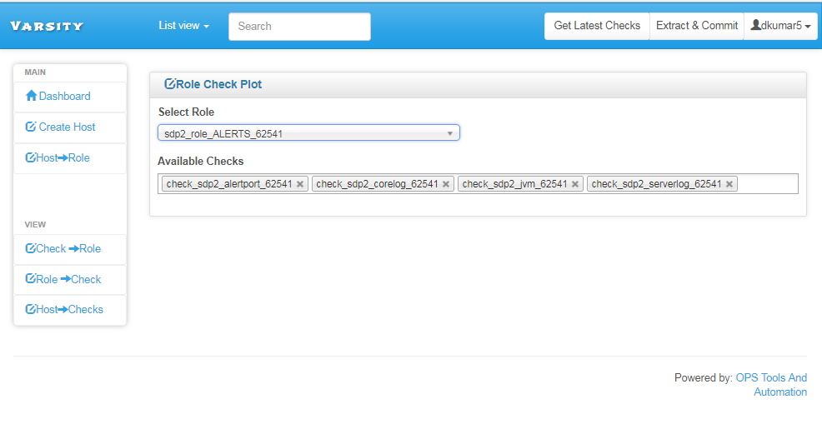

# Viewing All ROLES for a CHECK

* To view all the roles under which a check is mapped go to Check->roles uner View menu. 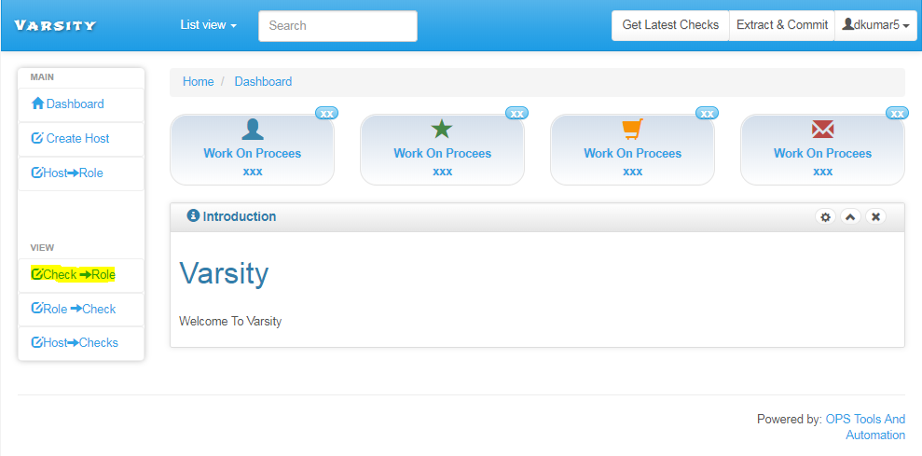
* Select the required checkname and the rolename will be populated automatically under Roles mapped textbox.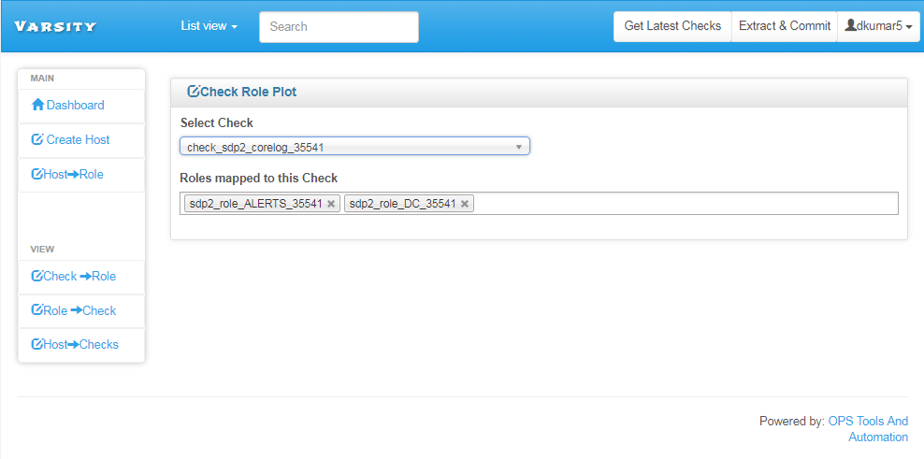

# VIEWING ALL (CURRENT)AcTIVE CHECKS ON A HOST

* To view all the Current Active Checks(from Uchiwa Dashboard), go to Host->Checks under View menu. 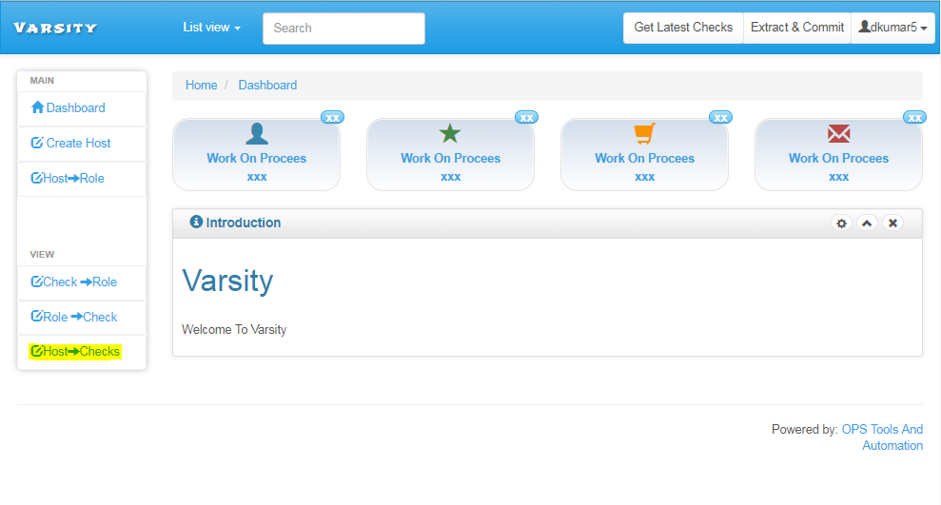
* Select the required hostname and Environment will be automatically displayed on the Screen.Click Submit to get the result on the Screen. 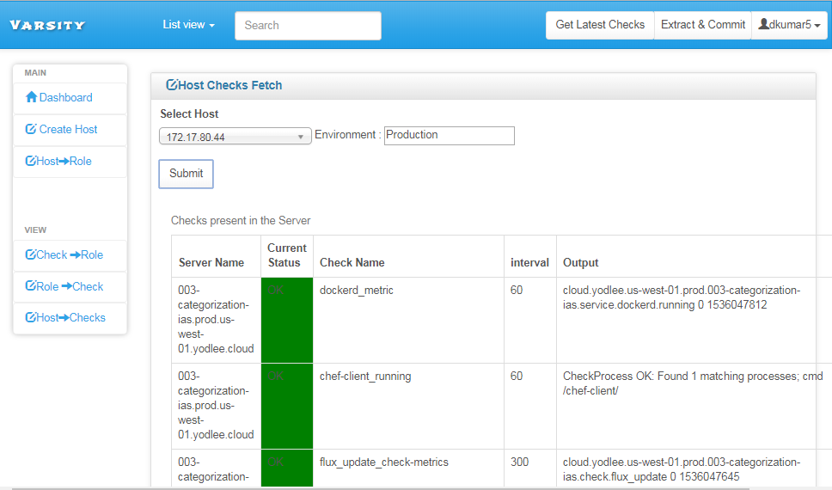

# Assigning/MODIFYing ROles for a HOST:

* For Adding/Removing Roles to a Server, Go to Host->Role under “Main” menu. 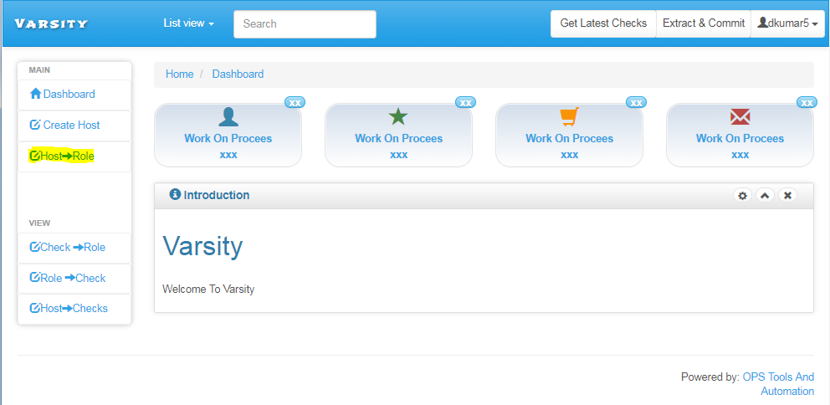
* Select the Hostname/Ip and the Roles will Auto populate in the TextBox. 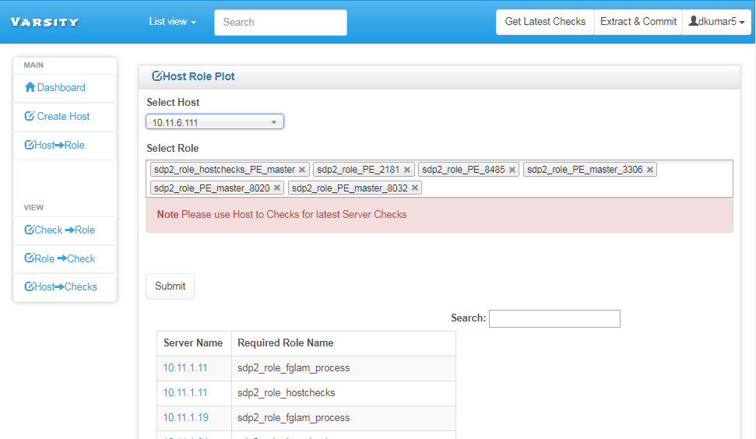
* Add/Remove any new role required to the Select Role textbox and Click Submit.You will get a success message as follows. 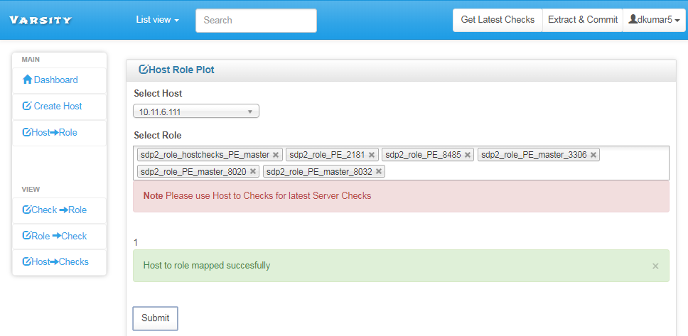
* After the required mapping is completed, Run the “Extract and Commit” button on the Right hand side of the screen to create the “final_files_sensuInstallation.tar” on the 172.17.31.152 Server which can be copied and installed on the required host. 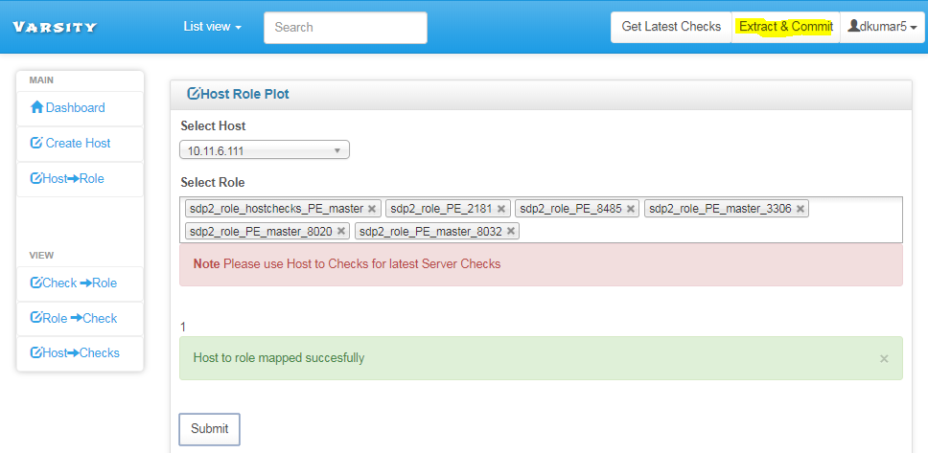

# GET ALL LATEST CHECKS

* Go to the HomePage and click on